RESTAURANT & DELICATESSEN
No. 1 Mitchel Street, Clonmel
www.niamhs.com niamhsweb@gmail.com

Office Catering

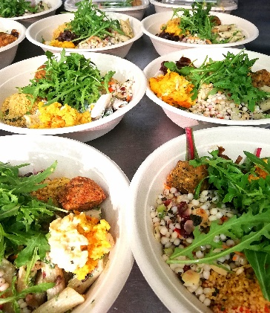

ENQUIRIES / ORDERS
Tel:052 6125698

RESTAURANT & DELICATESSEN
No. 1 Mitchel Street, Clonmel
www.niamhs.com niamhsweb@gmail.com

Office Catering

ENQUIRIES / ORDERS
Tel:052 6125698

RESTAURANT & DELICATESSEN
No. 1 Mitchel Street, Clonmel
www.niamhs.com niamhsweb@gmail.com

Office Catering

ENQUIRIES / ORDERS
Tel:052 6125698

RESTAURANT & DELICATESSEN
No. 1 Mitchel Street, Clonmel
www.niamhs.com niamhsweb@gmail.com
OFFICE CATERING
Flahavan’s Porridge ……..…………………………..€2.60
Granola & Yogurt Cup With banana & berry compote..€4.25
Freshly baked scone ……..……………..…………..€1.60
With jam, butter & cream .………………………..…..€2.40

Sausage Roll…………………………………..………….€1.40

Platter of freshly cut sandwiches ……..….…€19.75
(contains 5 sandwiches)
Platter of Wraps & Baps…………….€4.95 per person
Platter of sweet treats ………………€2.50 per person
Homemade Quiche & Artisan Salads.…€8.50per person
Homemade Soup & Brown Brown………€4.10per person
Artisan Salad Bowls

Small Bowl €5.50

Medium Bowl €6.50

Large Protein + salad Bowl €8.50

ENQUIRIES / ORDERS
Tel:052 6125698
Please give 24 hours notice
Delivery can be organised with taxi service, €9.95 per drop

RESTAURANT & DELICATESSEN
No. 1 Mitchel Street, Clonmel
www.niamhs.com niamhsweb@gmail.com
OFFICE CATERING
Flahavan’s Porridge ……..…………………………..€2.60
Granola & Yogurt Cup With banana & berry compote..€4.25
Freshly baked scone ……..……………..…………..€1.60
With jam, butter & cream .………………………..…..€2.40

Sausage Roll…………………………………..………….€1.40

Platter of freshly cut sandwiches ……..….…€19.75
(contains 5 sandwiches)
Platter of Wraps & Baps…………….€4.95 per person
Platter of sweet treats ………………€2.50 per person
Homemade Quiche & Artisan Salads.…€8.50per person
Homemade Soup & Brown Brown………€4.10per person
Artisan Salad Bowls

Small Bowl €5.50

Medium Bowl €6.50

Large Protein + salad Bowl €8.50

ENQUIRIES / ORDERS
Tel:052 6125698
Please give 24 hours notice
Delivery can be organised with taxi service, €9.95 per drop

RESTAURANT & DELICATESSEN
No. 1 Mitchel Street, Clonmel
www.niamhs.com niamhsweb@gmail.com
OFFICE CATERING
Flahavan’s Porridge ……..…………………………..€2.60
Granola & Yogurt Cup With banana & berry compote..€4.25
Freshly baked scone ……..……………..…………..€1.60
With jam, butter & cream .………………………..…..€2.40

Sausage Roll…………………………………..………….€1.40

Platter of freshly cut sandwiches ……..….…€19.75
(contains 5 sandwiches)
Platter of Wraps & Baps…………….€4.95 per person
Platter of sweet treats ………………€2.50 per person
Homemade Quiche & Artisan Salads.…€8.50per person
Homemade Soup & Brown Brown………€4.10per person
Artisan Salad Bowls

Small Bowl €5.50

Medium Bowl €6.50

Large Protein + salad Bowl €8.50

ENQUIRIES / ORDERS
Tel:052 6125698
Please give 24 hours notice
Delivery can be organised with taxi service, €9.95 per drop

